1. Create an Employee table with Emp_no int, Emp_name varchar(20).

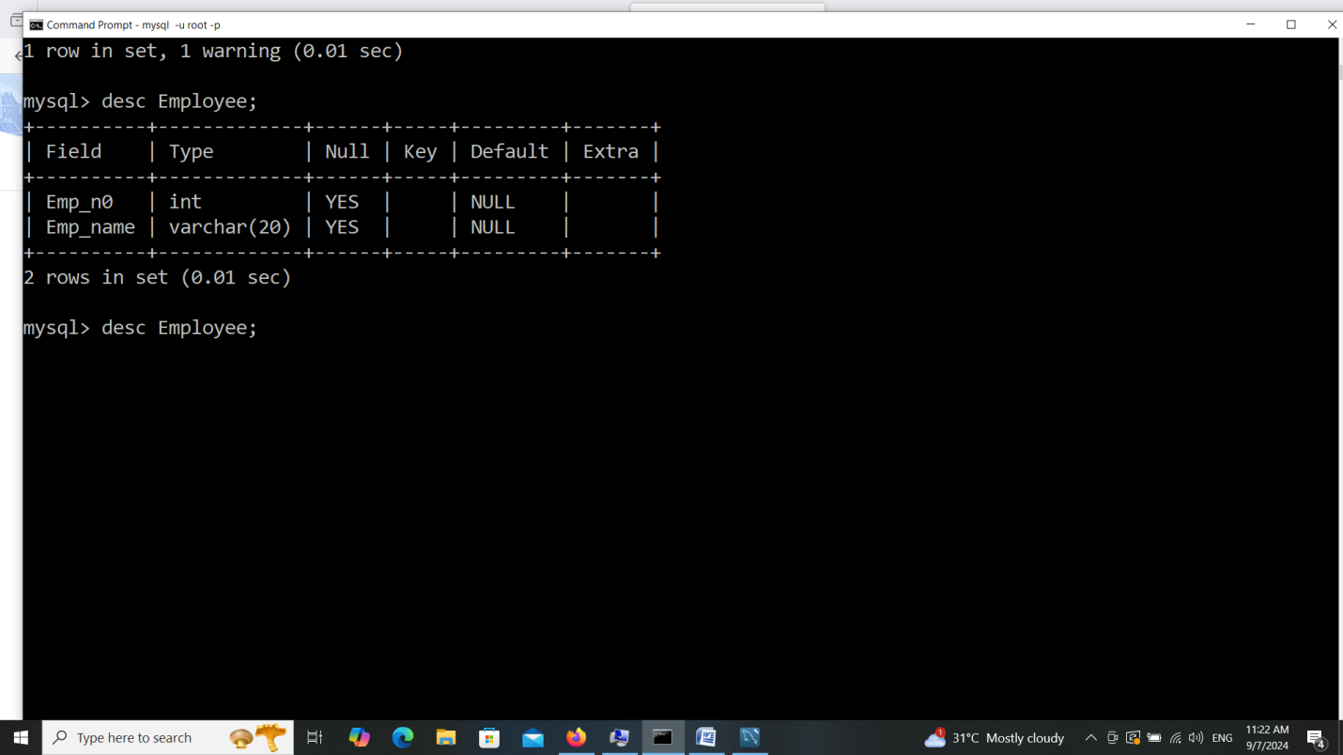

2. Add Dept varchar(20) column to Employee Table.

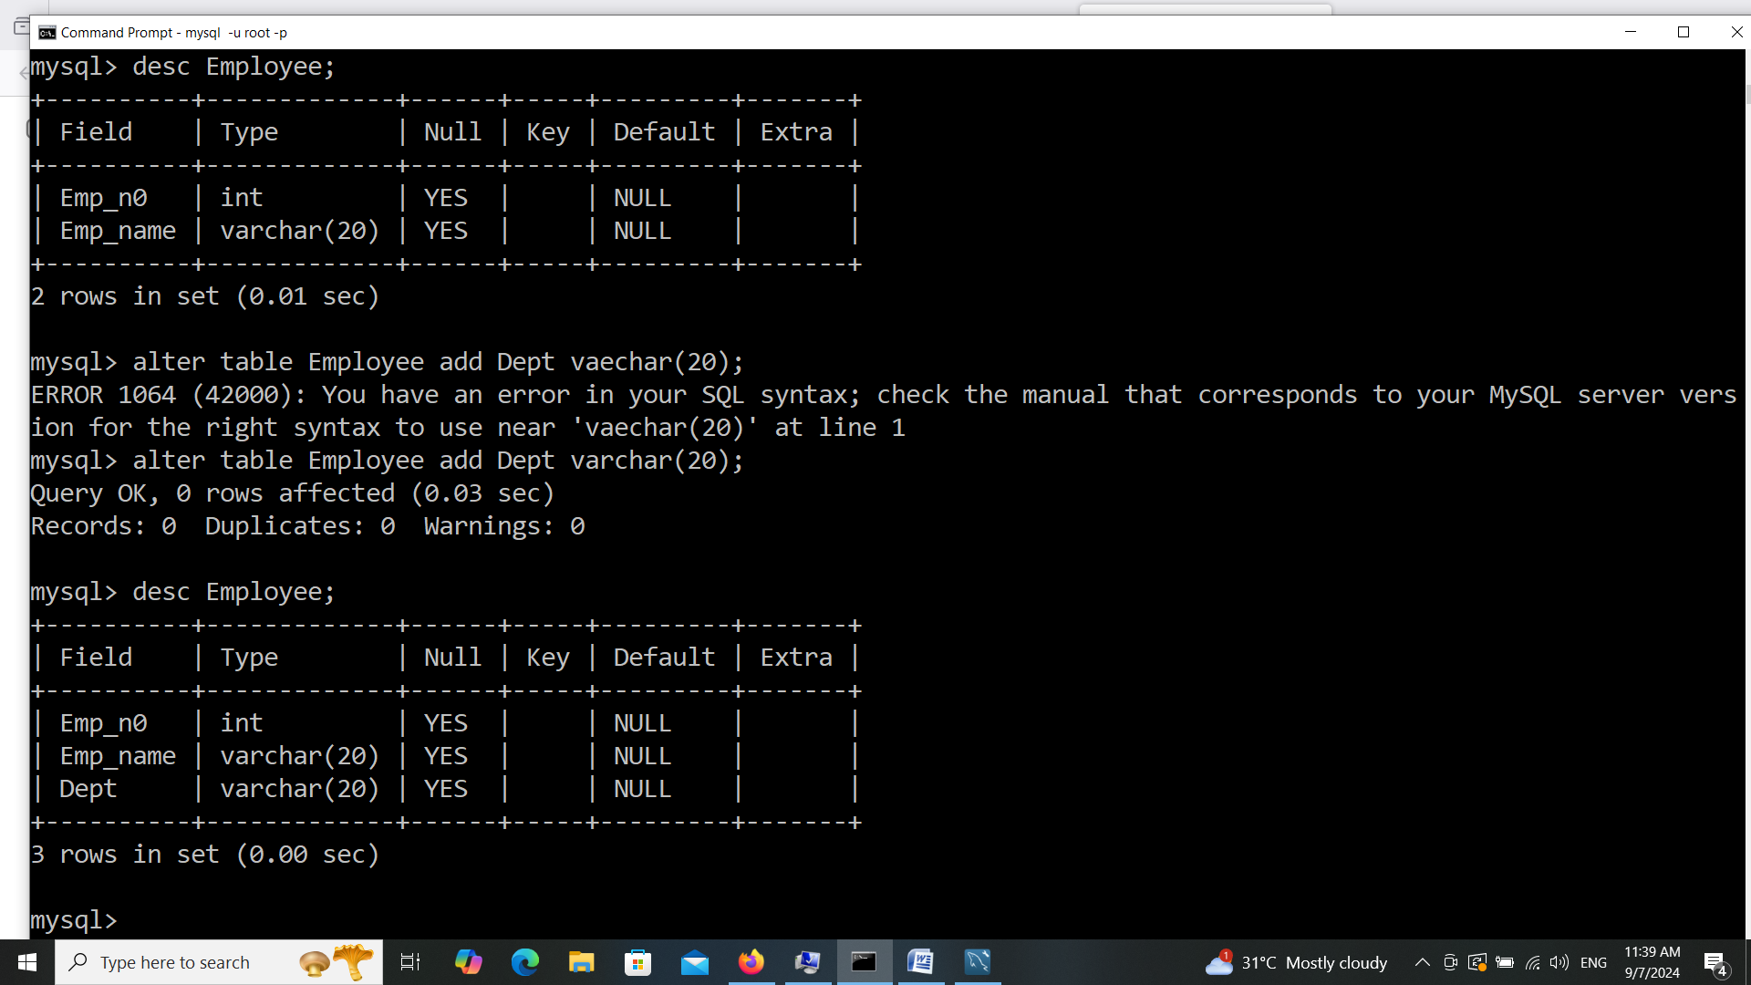

3. Add Salary float(4,2) and age varchar(5) column to Employee Table.

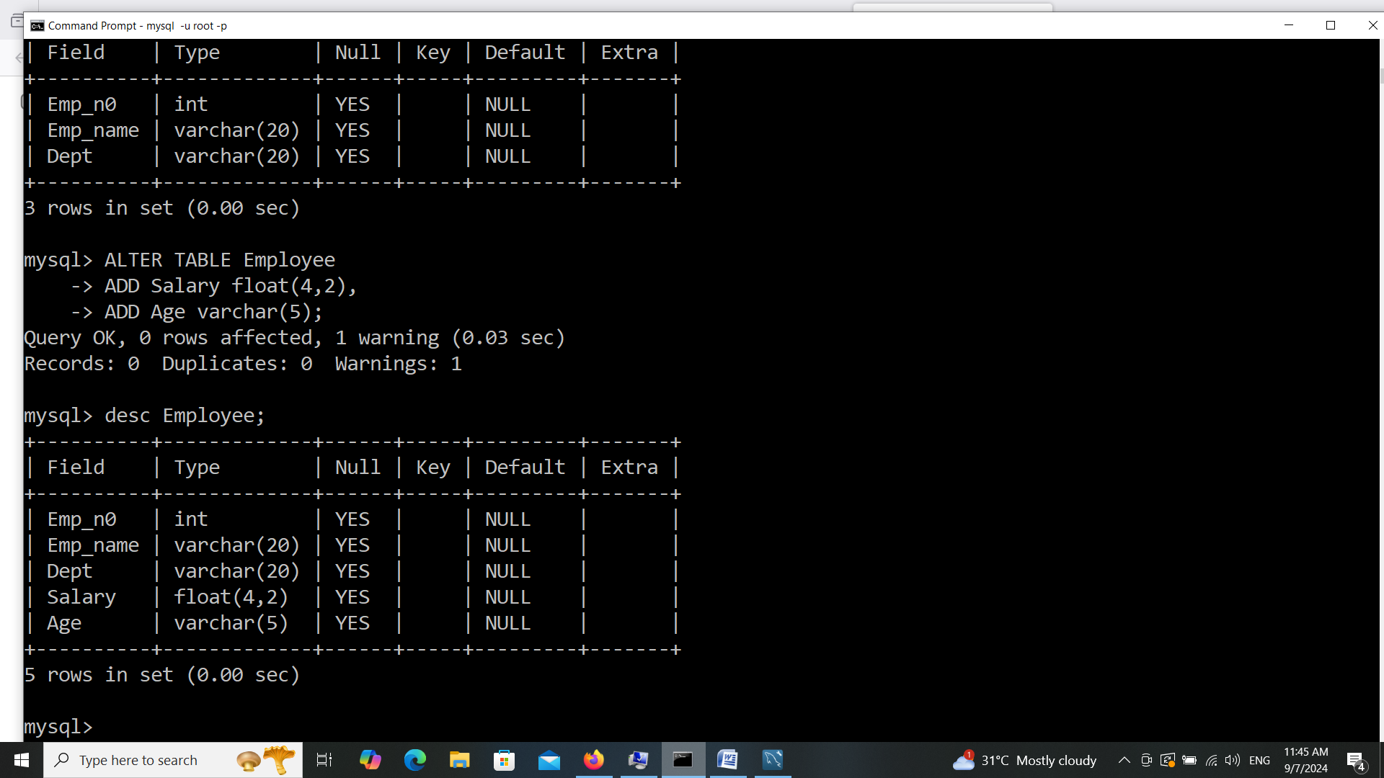

4. Modify column age data type to int.

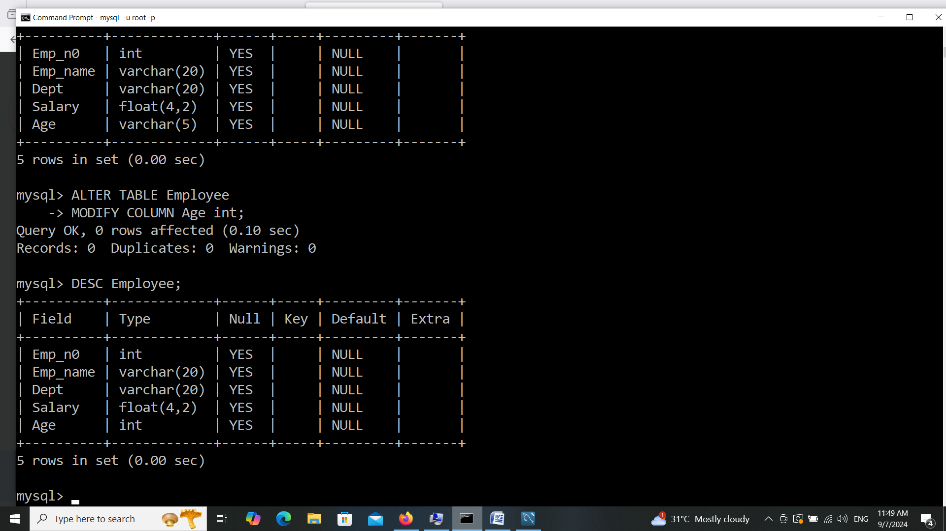

5. Rename column Dept to Dept_id.

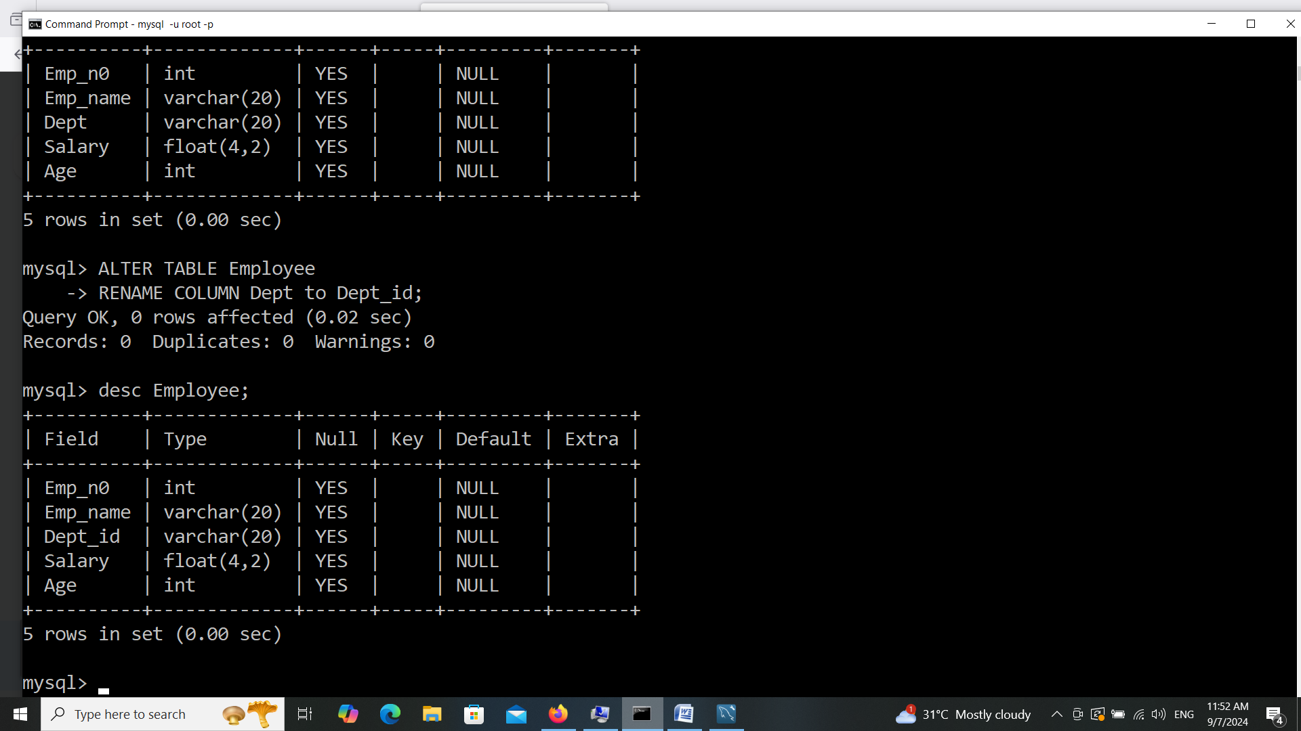

6. Insert four to five records into the Employee table.

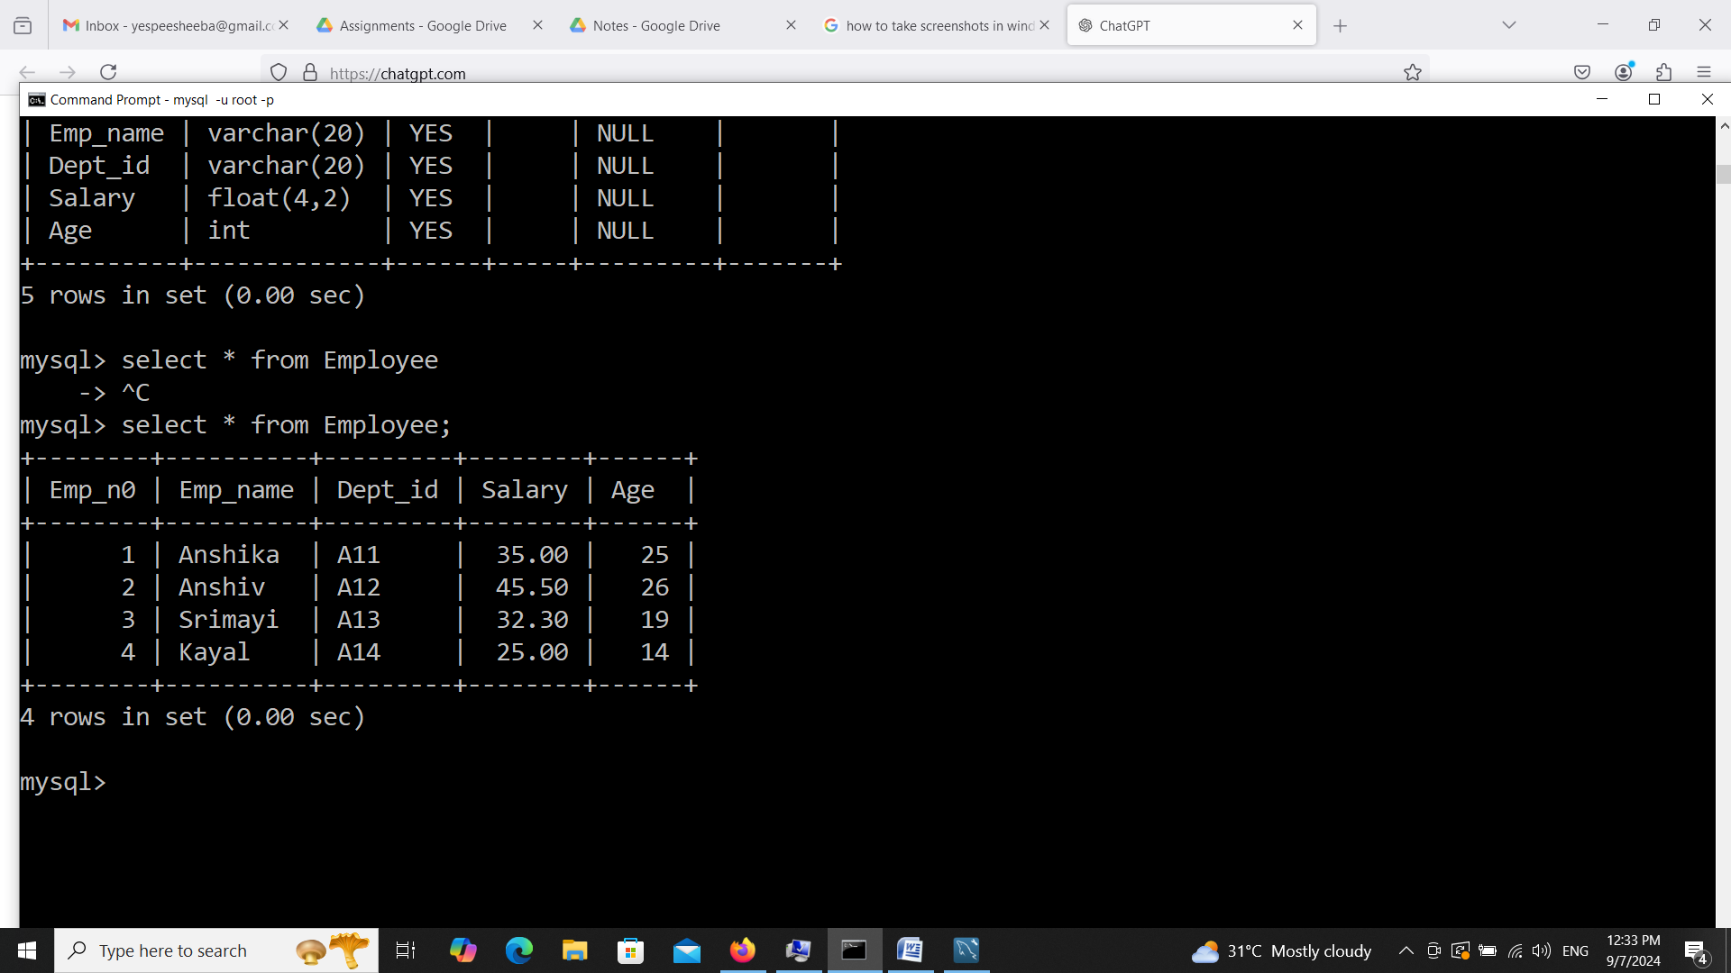

7. Delete one record from the employee table.

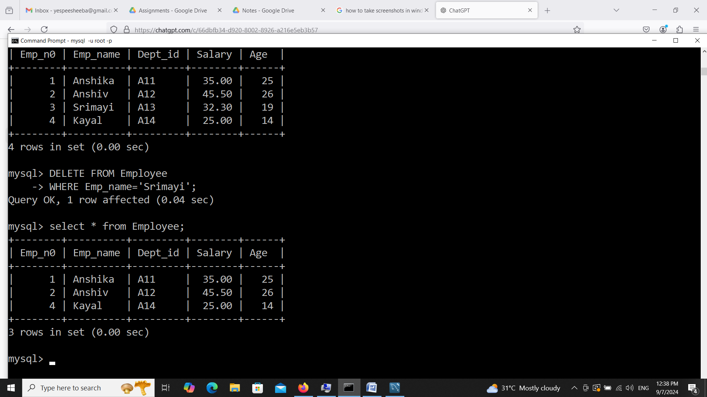

8. Use the truncate method.

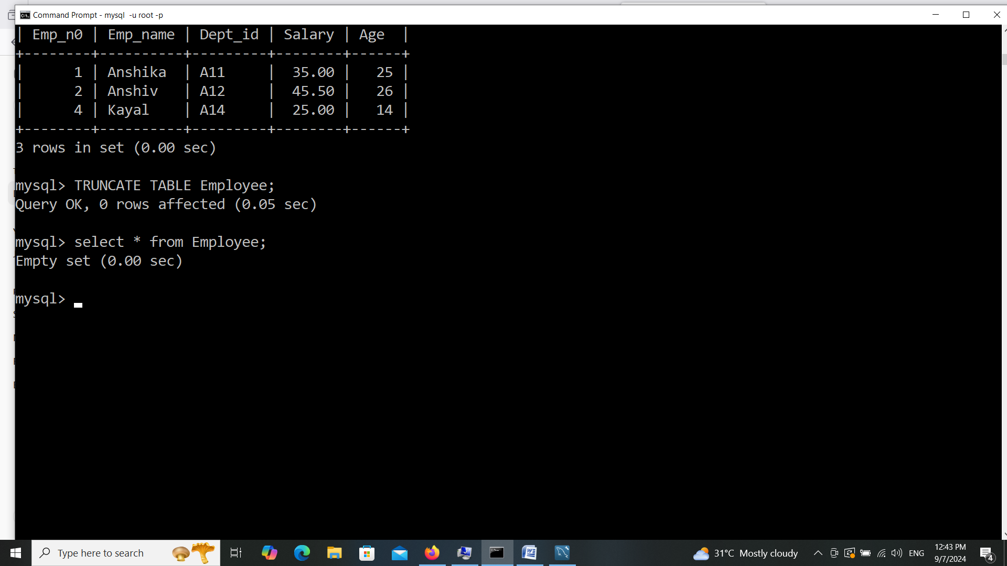

9. Drop employee table.

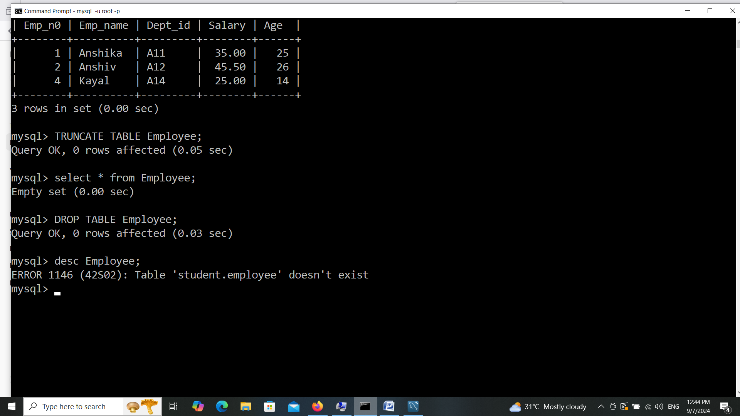

10.Create an Employee table with Emp_no, Emp_name, Dept_id, Salary and age use

constraints NOT NULL, Emp_no as PRIMARY KEY, Default value for Salary 40000

and Check constraint age > 20.

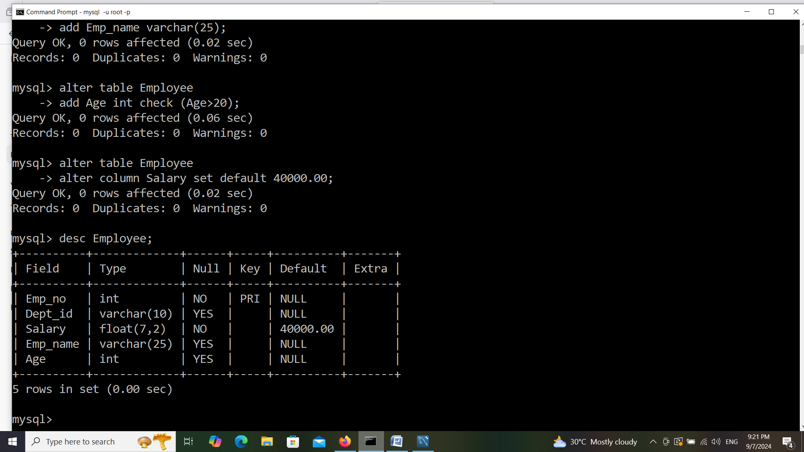

11.Create a Department table with ID int, Dept_id int, Dept_name varchar(20), Location

varchar(15) use auto increment for id starts with 100, Default Location value ‘New

Delhi’.

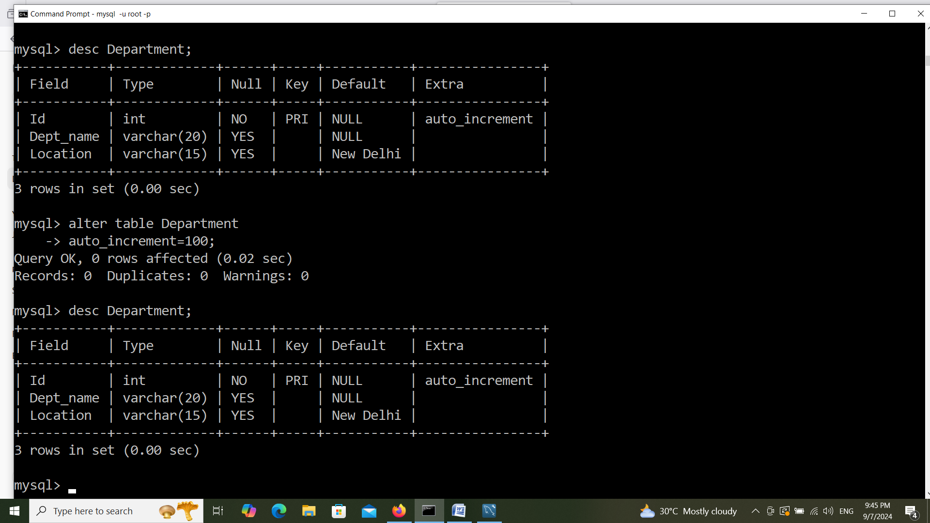

13. Insert values into employee and department tables.

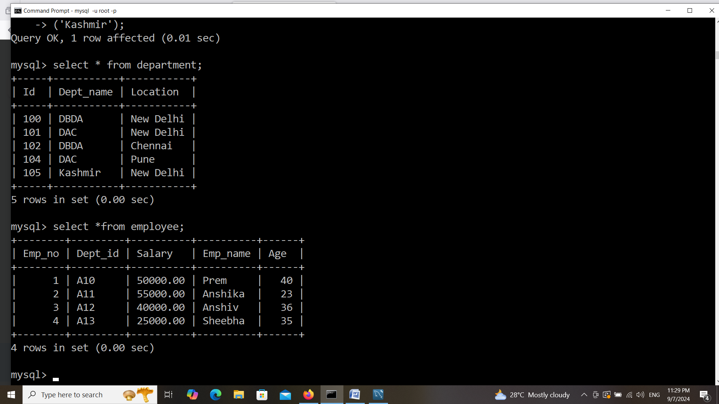

15. Select only Emp_no, Emp_name and Salary.

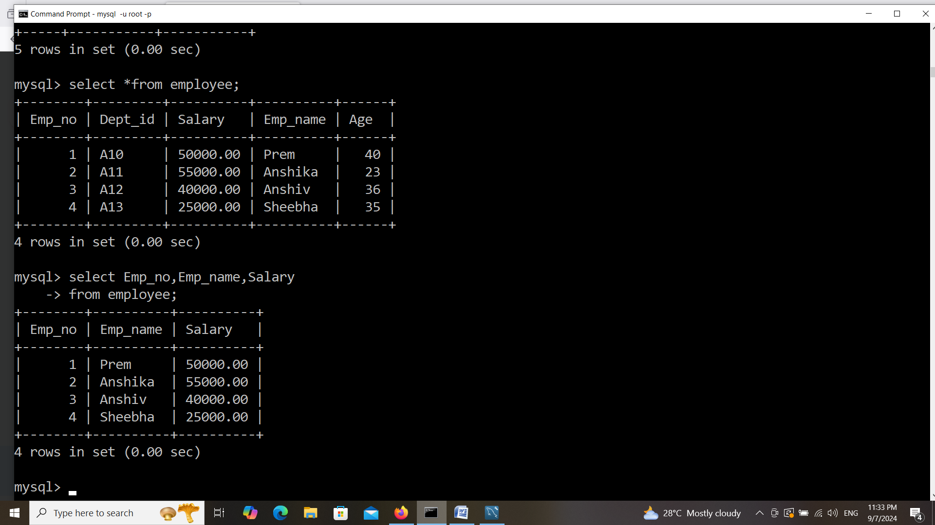

16.Update salary by adding Rs.1000 bonus applicable to employees whose salary is

less than Rs.50000/-.

